Google Maps Add API (POST):
This API Will add new place into Server

Complete URL : https://rahulshettyacademy.com/maps/api/place/add/json?key= qaclick123

Base URL: https://rahulshettyacademy.com
Resource: /maps/api/place/add/json
Query Parameters: key =qaclick123
Http Method: POST
Sample Body :
{
"location": {
"lat": -38.383494,
"lng": 33.427362
},
"accuracy": 50,
"name": "Frontline house",
"phone_number": "(+91) 983 893 3937",
"address": "29, side layout, cohen 09",
"types": [
"shoe park",
"shop"
],
"website": "http://google.com",
"language": "French-IN"
}

Sample Response

{
"status": "OK",
"place_id": "928b51f64aed18713b0d164d9be8d67f",
"scope": "APP",
"reference": "736f3c9bec384af62a184a1936d42bb0736f3c9bec384af62a184a1936d42bb0",
"id": "736f3c9bec384af62a184a1936d42bb0"
}

Google Maps Delete API (POST):
This API Will delete existing place from Server

Complete URL: https://rahulshettyacademy.com/maps/api/place/delete/json?key=qaclick123

Base URL: https://rahulshettyacademy.com
Resource: /maps/api/place/delete/json
Query Parameters: key
Http request : DELETE

Sample Body :
{
"place_id":"928b51f64aed18713b0d164d9be8d67f"
}
Sample Response
{
"status": "OK"
}

Google Maps get Place API (GET):
This API Will get existing place details from Server

Complete URL : http://rahulshettyacademy.com/maps/api/place/get/json?place_id=xxxx&key=qaclick123

Base URL: https://rahulshettyacademy.com
Resource: /maps/api/place/get/json
Query Parameters: key, place_id //( place_id value comes from Add place response)
Http request: GET
Note: Key value is hardcoded and it is always qaclick123
Sample Response for the Provided Place_Id
{

"location":{

"lat" : -38.383494,

"lng" : 33.427362

},

"accuracy":50,

"name":"Frontline house",

"phone_number":"(+91) 983 893 3937",

"address" : "29, side layout, cohen 09",

"types": ["shoe park","shop"],

"website" : "http://google.com",

"language" : "French-IN"

}

Google Maps Put Place API (PUT):
This API Will update existing place in Server with new values

Complete URL: http://rahulshettyacademy.com/maps/api/place/get/json?place_id=xxxx&key=qaclick123

Base URL : https://rahulshettyacademy.com
Resource: /maps/api/place/update/json
Query Parameters: key
Http Method: PUT -
Note: Key value is hardcoded and it is always qaclick123

Sample Request:
{
"place_id":"8d2573bdf6ceec0e474c5f388fa917fb",
"address":"70 Summer walk, USA",
"key":"qaclick123"
}

Sample Response for the Provided Place_Id
{

"location":{

"lat" : -38.383494,

"lng" : 33.427362

},

"accuracy":50,

"name":"Frontline house",

"phone_number":"(+91) 983 893 3937",

"address" : "29, side layout, cohen 09",

"types": ["shoe park","shop"],

"website" : "http://google.com",

"language" : "French-IN"

}

Automating the API Methods (GET/PUT/POST/DELETE)

Prerequisite - Eclipse settings before starting to write the automation code.
Dependent packages required.
import io.restassured.RestAssured;
import static io. restassured.RestAssured.*;

Both the above packages are needed as there are some static menthods also available in the io.restassured.RestAssured.

given().queryParam("key", "qaclick123").header("Content-Type","application/json")
.body("”)
In the given code, the body("") method accepts input as a String. Since the payload contains key-value pairs enclosed in double quotes, we need to use escape characters (\) to ensure the quotes are interpreted correctly. This escaping can be handled automatically by the Eclipse editor if it is configured properly, as shown in the screenshot below.

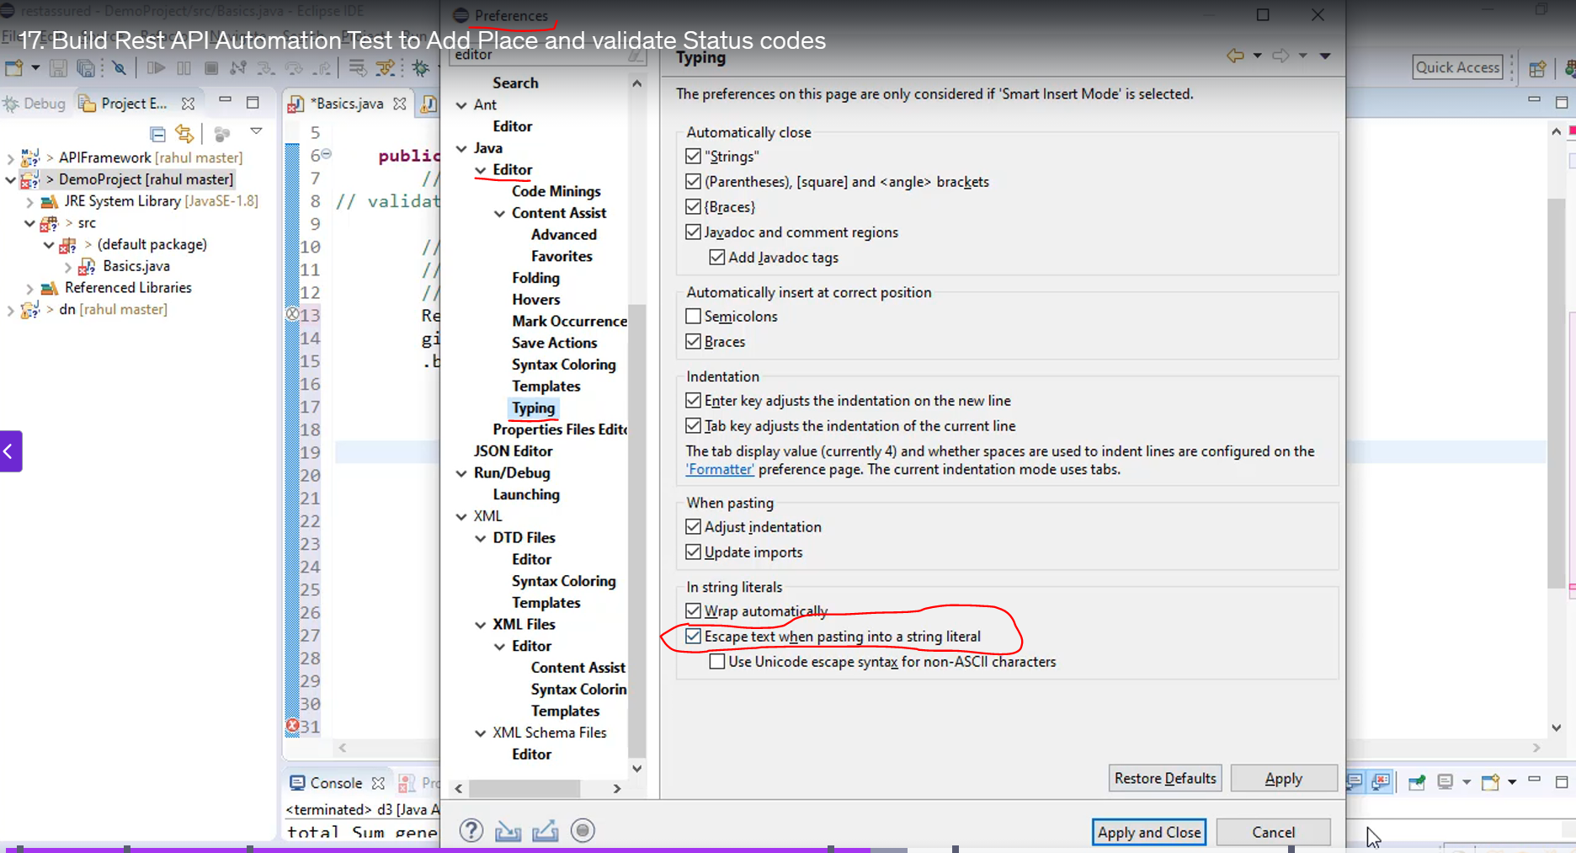
When we paste the payload in between the double quotes in body ("") method the payload would look like the below snippet of code.
RestAssured.baseURI = "https://rahulshettyacademy.com";
given().queryParam("key", "qaclick123").header("Content-Type","application/json")
.body("\"location\": {\r\n"
+ " \"lat\": -38.383494,\r\n"
+ " \"lng\": 33.427362\r\n"
+ " },\r\n"
+ " \"accuracy\": 50,\r\n"
+ " \"name\": \"Frontline house\",\r\n"
+ " \"phone_number\": \"(+91) 983 893 3937\",\r\n"
+ " \"address\": \"29, side layout, cohen 09\",\r\n"
+ " \"types\": [\r\n"
+ " \"shoe park\",\r\n"
+ " \"shop\"\r\n"
+ " ],\r\n"
+ " \"website\": \"http://google.com\",\r\n"
+ " \"language\": \"French-IN\"\r\n"
+ "}\r\n"
+ "");

Here’s what each part of your Rest Assured code does, step by step:

RestAssured.baseURI = "https://rahulshettyacademy.com";
given()
.log().all()
.queryParam("key", "qaclick123")
.header("Content-Type", "application/json");

1) RestAssured.baseURI = "https://rahulshettyacademy.com";
- Sets the base URI for all subsequent requests.
- This means you can call endpoints by path only (e.g., /maps/api/place/add/json) without repeating the full URL.
- If you later do when().post("/something"), the full request will go to https://rahulshettyacademy.com/something.

2) given()
- given() starts the request specification.
- log().all() logs the entire request (method, URL, headers, body, etc.).
- queryParam("key", "qaclick123") appends ?key=qaclick123 to the request URL.
- header("Content-Type","application/json") declares the request body format.
- body(...) adds the JSON payload for the POST request.

3) log().all()
- Enables logging of everything about the request before it is sent:
  - Method, URL, query params, headers, cookies, and body.
- Very useful for debugging to see exactly what you’re sending.

4) queryParam("key", "qaclick123")
- Adds a query parameter to the request, resulting in ?key=qaclick123 appended to the URL.
- Example final URL (after you add a path in when()):
https://rahulshettyacademy.com/maps/api/place/add/json?key=qaclick123

5) .header("Content-Type", "application/json")
- Sets the Content-Type header to application/json.
- This tells the server that the request body (if you include one) is JSON.
- Typically paired with .body(...) when sending payloads (e.g., POST/PUT).

• given() starts the request specification.
• .log().all() logs the entire request (method, URL, headers, body, etc.).
• .queryParam("key", "qaclick123") appends ?key=qaclick123 to the request URL.
• .header("Content-Type","application/json") declares the request body format.
• .body(...) adds the JSON payload for the POST request.

Steps to follow to verify API
- Set Base URI
- Build the Request
- Send the Request
- Validate the Response
  - Status code
  - Response Body
Note: For every API we have to have a separate set of given(), when() & then(). We can have multiple API validations within a single class file.

Parsing Complex Json
JSON files store data in a key–value pair structure. While working with JSON can seem straightforward when the data is organized at a single, flat level, it can quickly become more complex when the structure contains nested objects or arrays.
In a simple JSON structure, each key maps directly to a value:
{
"id": 101,
"name": "Product A",
"price": 25.99
}
However, a complex/nested Json looks as below
{
"dashboard": {
"purchaseAmount": 910,
"website": "rahulshettyacademy.com"
},
"courses": [
{
"title": "Selenium Python",
"price": 50,
"copies": 6
},
{
"title": "Cypress",
"price": 40,
"copies": 4
},
{
"title": "RPA",
"price": 45,
"copies": 10
}
]
}

complexJsonParsing.java
package Files;

import io.restassured.path.json.JsonPath;

public class ComplexJsonParse {

public static void main(String[] args) {
// TODO Auto-generated method stub

JsonPath js=new JsonPath(payload.CoursePrice());
//Print No of courses returned by API

int count= js.getInt("courses.size()");
System.out.println(count);
//Print Purchase Amount
int totalAmount= js.getInt("dashboard.purchaseAmount");
System.out.println(totalAmount);
//Print Title of the first course

String titleFirstCourse=js.get("courses[2].title");
System.out.println(titleFirstCourse);

//Print All course titles and their respective Prices

for(int i=0;i<count;i++)
{
String courseTitles=js.get("courses["+i+"].title");
System.out.println(js.get("courses["+i+"].price").toString());

System.out.println(courseTitles);

}
//Print no of copies sold by RPA Course

System.out.println("Print no of copies sold by RPA Course");

for(int i=0;i<count;i++)
{
String courseTitles=js.get("courses["+i+"].title");
if(courseTitles.equalsIgnoreCase("RPA"))
{
int copies=js.get("courses["+i+"].copies");
System.out.println(copies);
break;
}

}

}

}

Payload used to parse
package Files;

public class payload {

public static String addPlace()
{
return"{\r\n"
+ " \"location\": {\r\n"
+ " \"lat\": -38.383494,\r\n"
+ " \"lng\": 33.427362\r\n"
+ " },\r\n"
+ " \"accuracy\": 50,\r\n"
+ " \"name\": \"Frontline house\",\r\n"
+ " \"phone_number\": \"(+91) 983 893 3937\",\r\n"
+ " \"address\": \"29, side layout, cohen 09\",\r\n"
+ " \"types\": [\r\n"
+ " \"shoe park\",\r\n"
+ " \"shop\"\r\n"
+ " ],\r\n"
+ " \"website\": \"http://google.com\",\r\n"
+ " \"language\": \"French-IN\"\r\n"
+ "}\r\n"
+ "";
}

public static String CoursePrice()
{

return "{\r\n" +
" \"dashboard\": {\r\n" +
" \"purchaseAmount\": 1162,\r\n" +
" \"website\": \"rahulshettyacademy.com\"\r\n" +
" },\r\n" +
" \"courses\": [\r\n" +
" {\r\n" +
" \"title\": \"Selenium Python\",\r\n" +
" \"price\": 50,\r\n" +
" \"copies\": 6\r\n" +
" },\r\n" +
" {\r\n" +
" \"title\": \"Cypress\",\r\n" +
" \"price\": 40,\r\n" +
" \"copies\": 4\r\n" +
" },\r\n" +
" {\r\n" +
" \"title\": \"RPA\",\r\n" +
" \"price\": 45,\r\n" +
" \"copies\": 10\r\n" +
" },\r\n" +
" {\r\n" +
" \"title\": \"Appium\",\r\n" +
" \"price\": 36,\r\n" +
" \"copies\": 7\r\n" +
" }\r\n" +
" \r\n" +
" \r\n" +
" \r\n" +
" ]\r\n" +
"}\r\n" +
"";
}

}

JsonPath is an alternative to using XPath for easily getting values from an Object document. It follows the Groovy syntax when getting an object from the document. You can regard it as an alternative to XPath for JSON.
JsonPath js = new JsonPath(payload.CoursePrice());
Creates a JsonPath object from a JSON string returned by payload.CoursePrice().
JsonPath (from Rest Assured) lets you query JSON fields using simple path expressions.

Automating the following testcases

Print No of courses returned by API
Printing the Json array size and its elements using the JsonPath.
Iterating through the Json Array and accessing the elements using Json Path.
JsonPath js=new JsonPath(payload.CoursePrice());
//Print No of courses returned by API

int count= js.getInt("courses.size()");
System.out.println(count);
//Print Purchase Amount
int totalAmount= js.getInt("dashboard.purchaseAmount");
System.out.println(totalAmount);
• JsonPath js = new JsonPath(payload.CoursePrice());
- Creates a JsonPath object from the JSON string returned by payload.CoursePrice().
• int count = js.getInt("courses.size()");
- Retrieves the size of the courses array from the JSON and stores it in count.
• System.out.println(count);
- Prints the number of courses.
• int totalAmount = js.getInt("dashboard.purchaseAmount");
- Extracts the purchaseAmount from the dashboard object in the JSON.
• System.out.println(totalAmount);
- Prints the purchase amount.

2.Print Purchase Amount

3. Print Title of the first course

4. Print All course titles and their respective Prices

5. Print no of copies sold by RPA Course

6. Verify if Sum of all Course prices matches with Purchase Amount
sumValidation

Automating the POST()
Post() can be automated by submitting a payload dynamically using a separate class file or by external source.
Basically, we will use 2 class files one for the scripting of test case the other for maintaining payload. Both the files are listed below .

Payload class file
package Files;
public class payload {
public static String addPlace()
{
return"{\r\n"
+ " \"location\": {\r\n"
+ " \"lat\": -38.383494,\r\n"
+ " \"lng\": 33.427362\r\n"
+ " },\r\n"
+ " \"accuracy\": 50,\r\n"
+ " \"name\": \"Frontline house\",\r\n"
+ " \"phone_number\": \"(+91) 983 893 3937\",\r\n"
+ " \"address\": \"29, side layout, cohen 09\",\r\n"
+ " \"types\": [\r\n"
+ " \"shoe park\",\r\n"
+ " \"shop\"\r\n"
+ " ],\r\n"
+ " \"website\": \"http://google.com\",\r\n"
+ " \"language\": \"French-IN\"\r\n"
+ "}\r\n"
+ "";
}

public static String CoursePrice()

{

return "{\r\n" +
" \"dashboard\": {\r\n" +
" \"purchaseAmount\": 1162,\r\n" +
" \"website\": \"rahulshettyacademy.com\"\r\n" +
" },\r\n" +
" \"courses\": [\r\n" +
" {\r\n" +
" \"title\": \"Selenium Python\",\r\n" +
" \"price\": 50,\r\n" +
" \"copies\": 6\r\n" +
" },\r\n" +
" {\r\n" +
" \"title\": \"Cypress\",\r\n" +
" \"price\": 40,\r\n" +
" \"copies\": 4\r\n" +
" },\r\n" +
" {\r\n" +
" \"title\": \"RPA\",\r\n" +
" \"price\": 45,\r\n" +
" \"copies\": 10\r\n" +
" },\r\n" +
" {\r\n" +
" \"title\": \"Appium\",\r\n" +
" \"price\": 36,\r\n" +
" \"copies\": 7\r\n" +
" }\r\n" +
" \r\n" +
" \r\n" +
" \r\n" +
" ]\r\n" +
"}\r\n" +
"";
}

public static String AddBook(String isbn, String aisle)

{

/*
* String payload = "{\r\n" + "\r\n" +
* "\"name\":\"Learn Appium Automation with Java\",\r\n\"isbn\":\""
* +isbn+"\", \r\n\"isle\":\""+aisle+"\",+ " + "\"author\":\"John foe\"\r\n" +
* "}\r\n" + "";
*/
String payload = "{\r\n" + "\r\n" + "\"name\":\"Learn Appium Automation with Java\",\r\n" + "\"isbn\":\""
+ isbn + "\",\r\n" + "\"aisle\":\"" + aisle + "\",\r\n" + "\"author\":\"John foe\"\r\n" + "}\r\n"
+ "";
return payload;
}
}

Testcase class file

package RestAssuredProject.RestAssuredProject;
import org.testng.annotations.DataProvider;
import org.testng.annotations.Test;
import Files.payload;
import Files.reusableMethods;
import io.restassured.RestAssured;
import io.restassured.path.json.JsonPath;
import static io.restassured.RestAssured.*;

public class DynamicJson {

@Test(dataProvider = "BooksData")
public void addBook(String isbn, String aisle)
{
RestAssured.baseURI = "http://216.10.245.166";
String response = given().header("Content-Type","application/json").
body(payload.AddBook("isbn", "aisle")).
when().post("Library/Addbook.php").
then().log().all().assertThat().statusCode(200).
extract().response().asString();

JsonPath js = reusableMethods.rawToJson(response);
String id = js.get("ID");
System.out.println(id);

}

@DataProvider(name="BooksData")
public Object[][] getData()
{
return new Object[][] {{"vbnf", "2354"}, {"jksdh","9872"}, {"ghjs", "7687"}};
}

}

DataProvider
- DataProvider methods play a crucial role in supplying test data for test methods in testing frameworks like TestNG. Here's how they work:
  - Defining a DataProvider: A DataProvider is typically a method that returns an array of objects. Each object can represent a set of data parameters for the test method.
  - Annotating the Method: You annotate the DataProvider method with @DataProvider to indicate that it supplies data. The main test method that uses this data is annotated with @Test alongside the dataProvider attribute that specifies the DataProvider method's name.
  - Multiple Data Sets: When you have multiple entries in your DataProvider method (arrays), the test method runs once for each data set. For instance, if the DataProvider returns three arrays, the test will execute three times, each time with the data from one of those arrays.
  - Accessing the Data: In the test method, you can access the data from the DataProvider by using parameters that correspond to the elements in the provided arrays. For example, if you provide arrays with book details, your test could use these details to perform assertions or actions relevant to each book.
  - Flexible Data Sourcing: While the DataProvider can hardcode data, it can also be extended to pull data from external sources like Excel files using libraries such as Apache POI, allowing for more dynamic and varied test scenarios.
Using DataProviders enhances the efficiency of your test cases, minimizing repetitive code and allowing you to test a variety of inputs easily.

Was this content relevant to you?

Serialization and Deserialization
In Rest Assured, serialization is the process of converting a Java object (usually a Plain Old Java Object, or POJO) into a data format like JSON or XML to be sent as a request body.
Deserialization is the reverse process: converting the API's JSON or XML response body back into a usable Java object.
Key Concepts
- POJO (Plain Old Java Object): A standard Java class used to represent the structure of your JSON or XML payload. It typically contains private fields, public getters, and setters for each field, and often a default constructor.
- Automatic Conversion: Rest Assured automatically performs the necessary conversions when a POJO is passed to the body() method for a request (serialization) or when using the as() method to cast a response to a POJO class (deserialization).
- Advantages:
Easy to parse and extract response (Json/xml) values if they are wrapped as Java object.
Java object is constructed with the support of POJO classes.
POJO classes are created based on the Request/Response payload.
- Additional Libraries required:
Jackson/Jackson2, Gson/Johnzon and JAXB.
- Jackson (Most Popular): The industry standard for JSON serialization/deserialization in Java.
- Gson (Google Gson): A simple, efficient library for JSON conversion.

Any JSON (Simple or Complex) to Graph Diagram || JSONVisio || OpenSource || Free
https://www.youtube.com/watch?v=ojfuvcVDGTg&list=PLFGoYjJG_fqp891lruz5fCRPWsDtEXJky&index=17

www.jsonvisio.com
https://omute.net/editor

What is Serialization and Deserialization?
Serialization is a conversion of the state of a Java object to a byte stream and Deserialization is the reverse of it i.e. conversion of a byte stream to corresponding Java object. A serialized object can be stored in files, external sources, databases etc and can also be transferred over networks.
To make a Java object serializable, either its class or any of its superclasses implements either the Serializable interface or its subinterface Externalizable. A class that implements Serializable or Externalizable are actually Java Beans.
A Plain Old Java Object i.e. POJO has no such restriction. We generally use POJOs to create JSON payload and convert JSON response payload to Java objects. Converting a POJO object to a JSON object is Serialization and converting a JSON object to a POJO object is called deserialization. These conversions can be done with help of Java libraries like Jackson, Gson etc. We don’t need to implement the required interfaces for POJO classes.
We will use Jackson Databind in this post. You can either download Jackson jar or use its dependency in your Maven/Gradle project.

Conversion of POJO Object to JSON Object in Rest Assured Using Jackson
I will create a very simple POJO as below:-

private String name;
private int age;

public String getName() {
return name;
}

public void setName(String name) {
this.name = name;
}

public int getAge() {
return age;
}

public void setAge(int age) {
this.age = age;
}

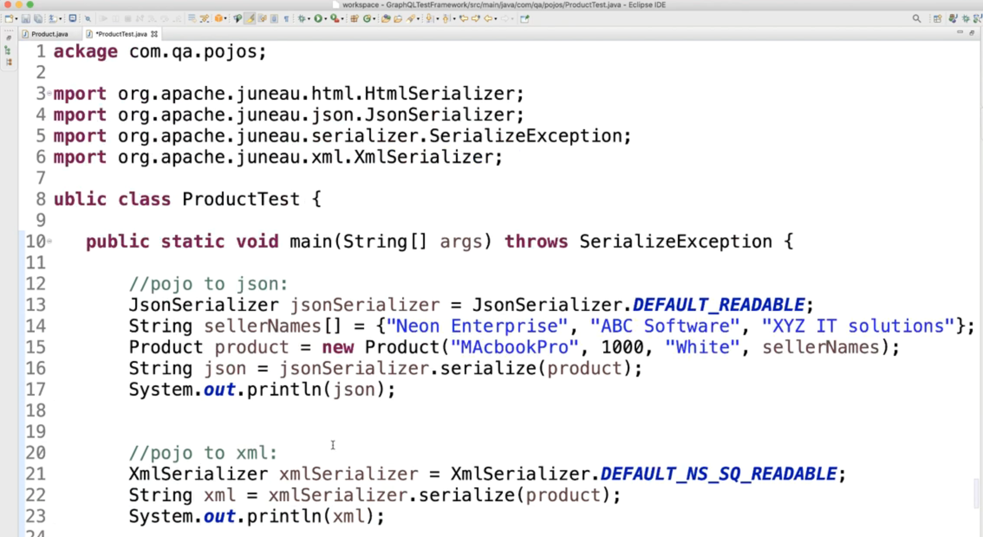

E2E E-Commerce API Automation Concepts

Login
- Navigate to the E-com portal : https://rahulshettyacademy.com/api/ecom/auth/login
- Register and/or Login and switch to developers mode.
- Switch Search for the Login call.
- Switch to Network tab, use Headers tab for URL of the portal , method to be automated, cookies to authenticate, etc.
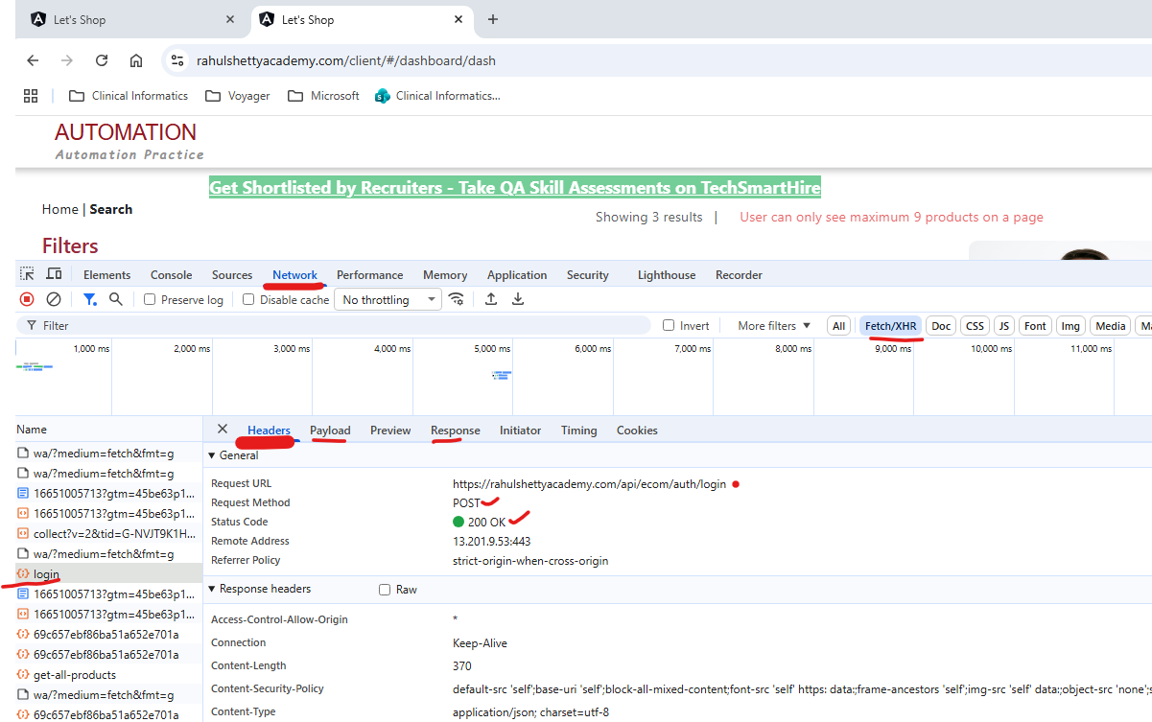

- Lets manually execute the testcase on postman before we automate it.
- Grab the URL from the Network tab.
- Switch to Payload tab and grab the payload source code by clicking on the source code and paste it in Postman under Body tab. Make sure to change the data format as Raw>>JSON. Paste the user details as payload in body section.
- 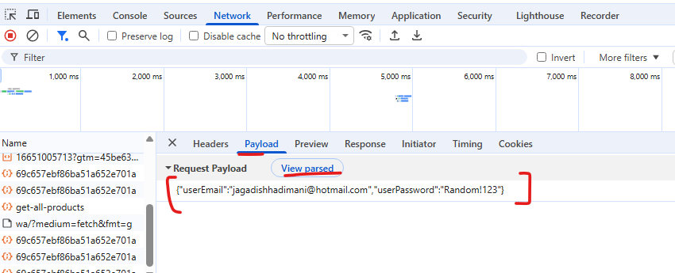
- When all the data needed to send the POST request is populated hit the Send button. Response should look as below with the token. This token/cookie will be used to identify the logged user throughout the session. Ex: in Post call we need to pass this token as Authorization token.
- In the response there is UserID and its value that will be used for identification on the user.
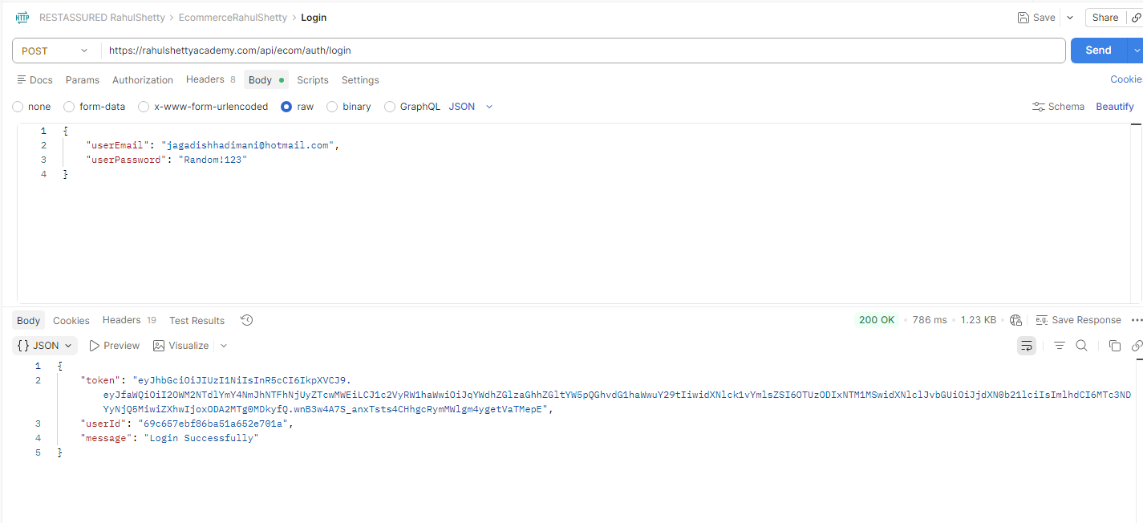

Add a new Product
Create Product contract details
Endpoint: https://rahulshettyacademy.com/api/ecom/product/add-product
HTTP method: POST
Form Data -

productName:qwerty
productAddedBy:{{userId}}
productCategory:fashion
productSubCategory:shirts
productPrice:11500
productDescription:Addias Originals
productFor:women

Self-Introduction

Hi my name is Jagadish Hadimani, I have overall experience of over 12 years as a Test Engineer, I am currently working with Photon infotech for the past 4 years as a QA lead engineer.
I am handling the E2E QA activities for a US based veterinary health provider company with 1100+ hospitals across the USA.
My roles and resposibilities in the current role include managing a team of 4 QA engineers and also contribute towards the sprint deliverables including Functional Testing, API testing and API Automation testing.
My expertise in testing includes Functional Testing, UI Automation Testing, API Testing using Postman and also the API automation testing.
I have used Java as the scripting language for both UI and API automation. I have used TestNG and BDD frameworks to automate the testcases.
I have experience handling the QA team and conduct all the Agile ceremonies while also taking care of producing the necessary documents like Test Strategy, Testplan and Test execution reports.
Also, when bugs are leaked, I am well versed with conducting the RCA and taking the necessary actions to patch the gap/ Improve the process we follow.

Hi, my name is Jagadish Hadimani. I have a total of 12 years of experience as a Test Engineer, and for the past 4 years I’ve been working at Photon Infotech as a QA Lead. In my current role, I handle end-to-end QA activities for a large US-based veterinary healthcare provider that operates over 1100+ hospitals across USA.
I lead a team of four QA engineers, and I also stay hands-on with sprint deliverables, including Functional Testing, API Testing, and API Automation. My technical expertise includes UI Automation and API Automation using Java, along with TestNG and BDD frameworks. I’ve worked extensively with Postman for API validation as well.
Beyond the technical work, I manage Agile ceremonies, prepare QA documentation such as test strategies, test plans, and execution reports, and perform RCA whenever there is defect leakage to help improve processes and prevent recurrence. Overall, I balance leadership with strong technical contribution, and I’m excited to discuss how my experience aligns with this role.

